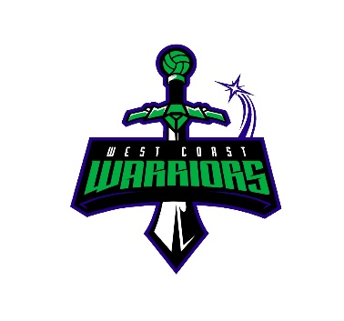
West Coast Warriors Netball Club (Inc)

Wanneroo Districts Netball Association (Inc)
PO Box 116
KINGSWAY WA 6065

Email: president.wcwarriors@gmail.com

Hello Warriors Cup Teams

Additional Warriors Cup Information

Thank you so much for participating in our carnival. Please take the time to read some important information about the carnival.

On arrival at the WDNA courts please head to our match office (located on veranda) and collect your score cards for the day. After each game is complete return score cards to match office.

Please endeavour to start exactly on time so games after yours start on time too. You are to time your own games, so please make sure you bring a timer. No central timing.

12U, 13U, 15U, 18U AND OPEN:
- Rules Shall be set as Per Official INF rules of Netball Rule Book unless otherwise stated. Also refer to WDNA Policies and Procedures at www.wdna.net.au.

NSG YR 2-YR 5:
- Rules are per WDNA rules (excluding length of quarters).

ALL TEAMS:
- Duration of matches: 2 x 12 min halves, 3 min half time break. There is NO injury time.
- All teams to provide a scorer/timer for each game. (Not centrally timed) Timer and scorer to sit together please. – first name team to score, second named team to time.
- Scorecards to be returned to match office after each game.
- Players names to be written on all scorecards, with positions.
- Points: 2 points for a win, 1 for a draw. In the event that teams finish on equal points at the end of the competition they will be separated by percentage (goals for and against).
- All teams to provide a COMPETENT umpire for all games. Umpires are expected to wear a white top and black/blue bottoms. Umpires will umpire their own teams.
- The team that finishes top of the ladder in the 12/U, 13/U, 15/U, 18/U and Open age groups, division 1 only, will be awarded the ‘Warriors Cup’ and a medallion. All other divisions - top of the ladder teams will receive a medallion. 10 medallions per team provided.

Presentations for top of the ladder will be held in the clubrooms, at the conclusion of last game.

Additional information:

- Team Withdrawal – No monies will be refunded unless event is cancelled by Warriors Committee.
- We do accept players that are NOT NWA affiliated, however they will need to pay for a $20.00 Single Game Voucher (SGV), which will cover their NWA affiliation fees for the carnival only. Payment for the SGV must be paid upon registration of the team.
- No jewellery permitted (includes piercings, cannot be taped) nails need to be short and smooth and cannot be taped. Gloves are allowed for open teams only.
- First Aid post available
- No strapping will be available.
- A canteen will be running with coffee, tea, hot choc, cold drinks, sausage sizzles, toasties, hot chips.
- A cake stall will be running until sold out, 100’s Clubs and raffles will be sold, Warriors merchandise will also be available for sale. Face painting and other activities provided.
- Tents may be erected on a first come first served basis. No portable bbqs allowed due to safety issues.
- We do have eftpos facilities.

We hope you enjoy the day and participate in the spirit of the game. 😊

